EC-231 Operating Systems
BS (CE)-2k21
Project Proposal Implementation of Page Replacement Algorithm

Submitted By:
Reg. No. | Name
21-CE-009 | Huzaifa Shahbaz
21-CE-021 | Yawar Ali Malik
21-CE-020 | Muhammad Ibthesam

Department of Computer Engineering
HITEC University Taxila

Engr.
Fasih Ahmed

Page Replacement Algorithm
Contents
Table of Figures: 4
Chapter#1 Abstract 5
1.1 Abstract: 5
Chapter#2 Introduction 6
2.1 Introduction: 6
Chapter#3 Problem Statement 6
3.1 Problem Statement: 6
Chapter#4 Objective 7
4.1 Objective: 7
Chapter#5 Expected Outcome 7
5.1 Expected Outcome: 7
Chapter#6 Components used 7
6.1 Components Used: 7
Chapter#7 Project Diagram 8
7.1 Project Diagram: 8
Chapter#8 First In, First Out (FIFO) 8
8.1 First In, First Out: 8
8.2 First In, First Out diagram: 8
8.3 CODE OF First In, First Out: 8
Chapter#9 Least Recently used (LRU) 10
9.1 Least Recently used (LRU): 10
9.2 Least Recently used (LRU) diagram: 10
9.3 CODE OF LEAST RECENTLY USED: 10
Chapter#10 Least Frequently Used (LFU) 12
10.1 Least Frequently Used (LFU): 12
10.2 Least Frequently Used (LFU) diagram: 12
10.3 CODE OF LEAST FREQUENTLY USED (LFU): 12
Chapter#11 Optimal Page Replacement 14
11.1 Optimal Page Replacement: 14
11.2 Optimal Page Replacement Diagram: 15
11.3 CODE OF Optimal Page Replacement: 15
Chapter#12 Code of page replacement algorithm 17
12.1 Code of page replacement algorithm: 17
Chpater#13 Results of page replacement algorithms 21
13.1 Results of page replacement algorithms: 21
Chapter#14 Conclusion of page replacement algorithm 21
14.1 Conclusion of page replacement algorithm: 21

Page Replacement Algorithm

Table of Figures:
Figure 7.1:Project diagram of page replacement algorithm 7
Figure8.2:First-In-first Out diagram of page replacement algorithm 8
Figure9 3:Least Recently used (LRU) diagram of page replacement algorithm 10
Figure 10.4:Least Frequently used diagram of page replacement algorithm 12
Figure11. 5:Optimal Page Replacement Algorithm diagram of page replacement algorithm 14
Figure 12.6:CODE OF PAGE REPLACMENT ALGORTHIM 21
Figure 7:RESULTS OF PAGE REPLACMENT ALGORTHIM OF FIFO,LRU,LFU AND OPTIMAL 21

Page Replacement Algorithm

Chapter#1 Abstract

Abstract:
Page replacement algorithms are critical for managing a computer's memory by deciding which pages to swap out when new pages need to be loaded. They aim to optimize performance by minimizing page faults. Common algorithms include FIFO (First-In-First-Out), LRU (Least Recently Used), and Optimal Page Replacement, each with distinct strategies for determining which page to replace. These algorithms balance efficiency and complexity to maintain effective memory utilization. Research in this area continues to evolve, enhancing system performance and resource management.

Chapter#2 Introduction

2.1 Introduction:
Paging is a type of memory management scheme which the computer uses to store and receive data from the secondary storage and uses that in the main memory. This scheme allows the physical address space of a process to be non-contiguous. E.g.
There is a process of size: 4
Bytes The size of a single page: 2
Bytes Number of pages/Process: 4/2 = 2
To follow the concept of paging the MMU makes a page table. Every process has its own page table. The number of pages in a page table is the same as the number of pages in a process.
E.g. The process 1 above, will have two entries in its page table. The page table however contains the “Frame No” which is the address in main memory where the data required is stored.

Chapter#3 Problem Statement

3.1 Problem Statement:
Developing a paging memory management system is essential for efficient data handling in computers. This project aims to design an optimized paging mechanism where the Memory Management Unit (MMU) maintains page tables for each process, correlating virtual addresses to physical memory locations. Challenges include optimizing page table size, minimizing access latency, and ensuring smooth data transfer between secondary and primary storage, providing an efficient solution for modern computing.

Chapter#4 Objective

4.1 Objective:
The objective of this project is to implement a paging memory management system to efficiently manage data in computer systems. This involves designing an optimized paging mechanism where the Memory Management Unit (MMU) maintains page tables for each process. The goal is to address challenges such as optimizing page table size, minimizing access latency, and ensuring seamless data transfer between secondary and primary storage, ultimately enhancing overall system performance and resource utilization.

Chapter#5 Expected Outcome

5.1 Expected Outcome:
The expected outcome of implementing an effective page replacement algorithm is a reduction in the number of page faults, leading to improved system performance and faster execution times. Enhanced memory utilization ensures that the most frequently accessed data is readily available, minimizing delays. This contributes to an overall smoother and more efficient operation of applications. Additionally, a well-chosen algorithm can extend the lifespan of hardware by reducing unnecessary wear from excessive data swapping.

Chapter#6 Components used

6.1 Components Used:
The Components used of page replacement algorithm following are:
1.Ubnutu
2.Sublime Text editor
3.GCC Compiler
4.Terminal

Chapter#7 Project Diagram

7.1 Project Diagram:
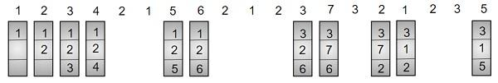
Figure 7.1:Project diagram of page replacement algorithm

Chapter#8 First In, First Out (FIFO)

8.1 First In, First Out:
This algorithm replaces the oldest page in memory when a page fault occurs. It keeps track of all pages in memory in a queue and when a page fault occurs, the page at the front of the queue is removed and a new page is added to the back of the queue.

8.2 First In, First Out diagram:
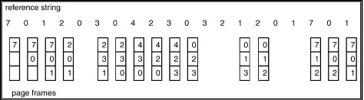 Figure8.2:First-In-first Out diagram of page replacement algorithm

8.3 CODE OF First In, First Out:
void fifo(int pages[], int n, int capacity)
{
int frame[capacity], front = 0, page_faults = 0;
for (int i = 0; i < capacity; i++)
frame[i] = -1;
for (int i = 0; i < n; i++)
{
int found = 0;
for (int j = 0; j < capacity; j++)
{
if (frame[j] == pages[i])
{
found = 1;
break;
}
}
if (!found)
{
frame[front] = pages[i];
front = (front + 1) % capacity;
page_faults++;
}
}
printf("FIFO Page Faults: %d\n", page_faults);
}

Chapter#9 Least Recently used (LRU)

9.1 Least Recently used (LRU):
The LRU page replacement algorithm replaces the least recently used page in the memory with a new page. The LRU page replacement algorithm is based on the assumption that among all pages in the memory, the least recently used page will not be used for a long time.

9.2 Least Recently used (LRU) diagram:
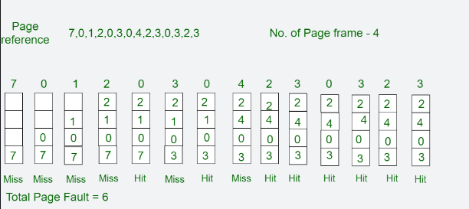
Figure9 3:Least Recently used (LRU) diagram of page replacement algorithm

9.3 CODE OF LEAST RECENTLY USED:
void lru(int pages[], int n, int capacity)
{
int frame[capacity], time[capacity], page_faults = 0, counter = 0;
for (int i = 0; i < capacity; i++)
frame[i] = -1;
for (int i = 0; i < n; i++)
{
int found = 0, lru_index = 0;
for (int j = 0; j < capacity; j++)
{
if (frame[j] == pages[i])
{
found = 1;
time[j] = ++counter;
break;
}
}
if (!found) {
int min_time = counter + 1;
for (int j = 0; j < capacity; j++)
{
if (time[j] < min_time)
{
min_time = time[j];
lru_index = j;
}
}
frame[lru_index] = pages[i];
time[lru_index] = ++counter;
page_faults++;
}
}
printf("LRU Page Faults: %d\n", page_faults);
}

Chapter#10 Least Frequently Used (LFU)

10.1 Least Frequently Used (LFU):
It removes the page that has not been utilized in the memory for the longest period of time. It replaces the least frequently used pages. It keeps track of page usage in the memory over a short time period.

10.2 Least Frequently Used (LFU) diagram:
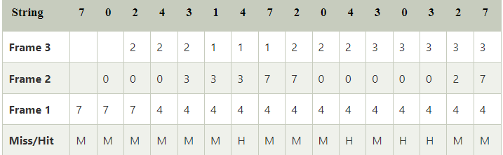
Figure 10.4:Least Frequently used diagram of page replacement algorithm

10.3 CODE OF LEAST FREQUENTLY USED (LFU):
void lfu(int pages[], int n, int capacity)
{
int frame[capacity], count[capacity], page_faults = 0;
for (int i = 0; i < capacity; i++)
{
frame[i] = -1;
count[i] = 0;
}
for (int i = 0; i < n; i++)
{
int found = 0, lfu_index = 0;
for (int j = 0; j < capacity; j++)
{
if (frame[j] == pages[i])
{
found = 1;
count[j]++;
break;
}
}
if (!found)
{
int min_count = n + 1;
for (int j = 0; j < capacity; j++)
{
if (frame[j] == -1)
{
lfu_index = j;
break;
}
else if (count[j] < min_count)
{
min_count = count[j];
lfu_index = j;
}
}
frame[lfu_index] = pages[i];
count[lfu_index] = 1;
page_faults++;
}
}
printf("LFU Page Faults: %d\n", page_faults);
}

Chapter#11 Optimal Page Replacement

11.1 Optimal Page Replacement:
The optimal page replacement (OPT) algorithm is a memory management technique. It minimizes the number of page faults by predicting future accesses and replacing the least recently used pages.

11.2 Optimal Page Replacement Diagram:
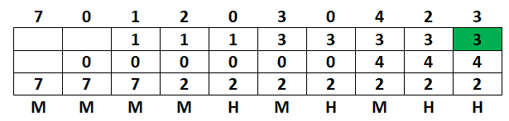
Figure11. 5:Optimal Page Replacement Algorithm diagram of page replacement algorithm

11.3 CODE OF Optimal Page Replacement:
void optimal(int pages[], int n, int capacity) {
int frame[capacity], page_faults = 0;
for (int i = 0; i < capacity; i++)
frame[i] = -1;
for (int i = 0; i < n; i++) {
int found = 0, replace_index = 0;
for (int j = 0; j < capacity; j++) {
if (frame[j] == pages[i]) {
found = 1;
break;
}
}
if (!found) {
int farthest = i + 1;
for (int j = 0; j < capacity; j++) {
int k;
for (k = i + 1; k < n; k++) {
if (frame[j] == pages[k])
break;
}
if (k == n) {
replace_index = j;
break;
} else if (k > farthest) {
farthest = k;
replace_index = j;
}
}
frame[replace_index] = pages[i];
page_faults++;
}
}
printf("Optimal Page Faults: %d\n", page_faults);
}

Chapter#12 Code of page replacement algorithm

12.1 Code of page replacement algorithm: 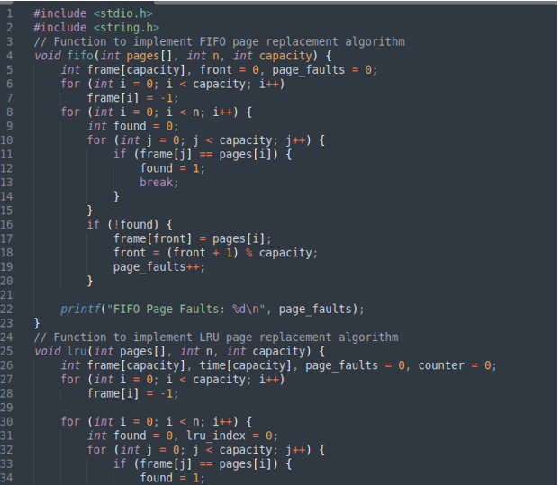
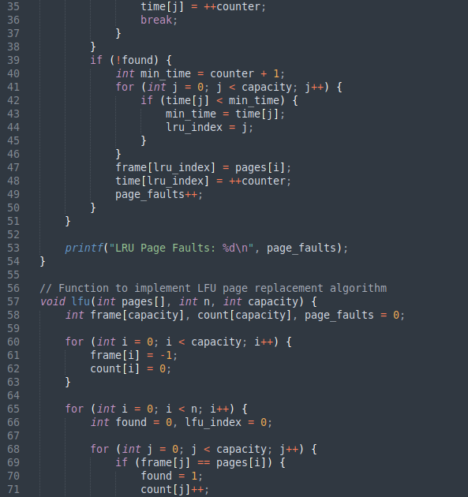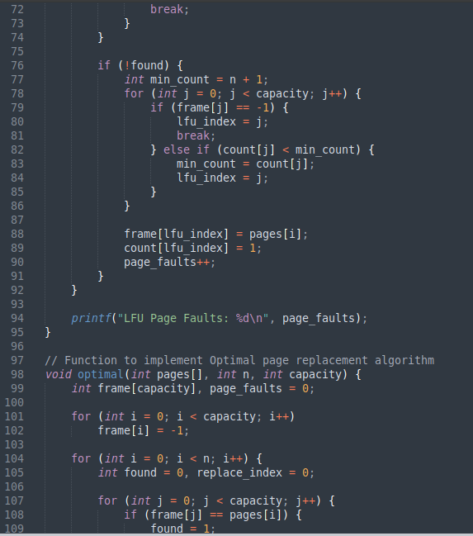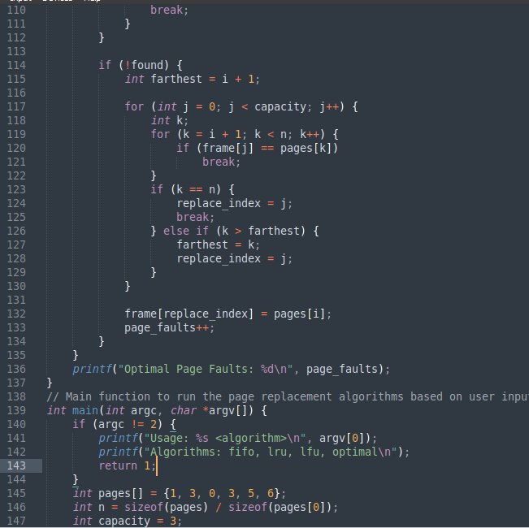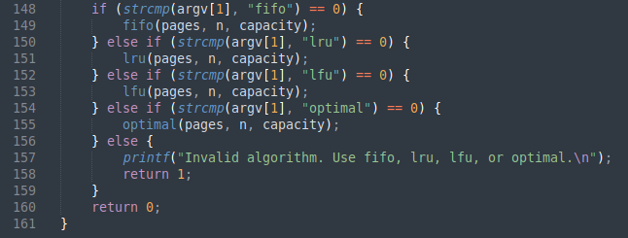
Figure 12.6:CODE OF PAGE REPLACMENT ALGORTHIM

Chpater#13 Results of page replacement algorithms

13.1 Results of page replacement algorithms:
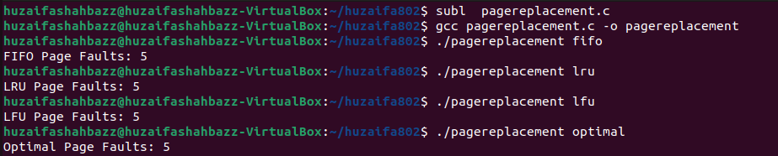
Figure 7:RESULTS OF PAGE REPLACMENT ALGORTHIM OF FIFO, LRU, LFU AND OPTIMAL

Chapter#14 Conclusion of page replacement algorithm

14.1 Conclusion of page replacement algorithm:
In conclusion, the developed paging memory management system optimizes data handling in computer systems. By maintaining page tables for each process, minimizing access latency, and ensuring efficient data transfer, overall system performance is enhanced. Further refinement will continue to advance modern computing technologies.

